EXPT NO: 4 | TRANSFER LEARNING USING PRE-TRAINED VISION MODELS FOR IMAGE RECOGNITION
DATE: 17-08-26

PRE-LAB QUESTIONS (PROVIDE BRIEF ANSWERS TO THE FOLLOWING QUESTIONS)
- What is transfer learning in deep learning?
Transfer learning is a technique where a model trained on a large dataset is reused for a new but related task. The pre-trained model's learned features are transferred to the new dataset.

- What are the advantages of using pre-trained models over training from scratch?
Pre-trained models require less training time, less data, and fewer computational resources. They can also provide better accuracy because they already contain useful learned features.

- What is the role of fine-tuning in transfer learning?
Fine-tuning involves unfreezing some layers of a pre-trained model and training them with the new dataset. It helps the model adapt its learned features to the new task.

- Name any three popular pre-trained computer vision models.
- ResNet50
- VGG16
- InceptionV3

- What is the purpose of Hugging Face and how is it useful in deep learning?
Hugging Face provides pre-trained AI models, datasets, and tools. It makes it easier to download, use, fine-tune, and deploy models for tasks such as image classification, object detection, and natural language processing.
AIM
To implement transfer learning using pre-trained vision models for image recognition and evaluate their performance on real-world image datasets.

SOFTWARE REQUIREMENTS
- Python
- TensorFlow/Keras or PyTorch
- Google Colab
- Hugging Face Transformers
- Kaggle Dataset
- Matplotlib
- GitHub

OBJECTIVES
Students will be able to:
- Understand the concept of transfer learning.
- Apply pre-trained vision models for image recognition.
- Fine-tune models such as ResNet or AlexNet.
- Utilize Kaggle datasets and Hugging Face vision models.
- Compare transfer learning performance with custom CNN models.

PROCEDURE
PART A: DATASET PREPARATION
Perform the following tasks:
- Download an image dataset from Kaggle.
- Load and preprocess the images.
- Split the dataset into training, validation, and testing sets.

PART B: IMPLEMENTING TRANSFER LEARNING
Load a pre-trained model such as:
- ResNet-50
- AlexNet
Replace the final classification layer according to the dataset classes.
Freeze the feature extraction layers.
Compile the model.

PART C: MODEL TRAINING AND PERFORMANCE EVALUATION
Train the transfer learning model.
Record:
- Training accuracy
- Validation accuracy
- Training loss
- Validation loss
- Test accuracy
Visualize:
- Accuracy vs Epoch
- Loss vs Epoch

PART D: USING HUGGING FACE PRE-TRAINED MODELS
Perform the following tasks:
- Load a pre-trained vision model from Hugging Face.
- Perform image classification on sample images.
- Compare predictions with the transfer learning model.
- Document observations and upload the notebook to GitHub.

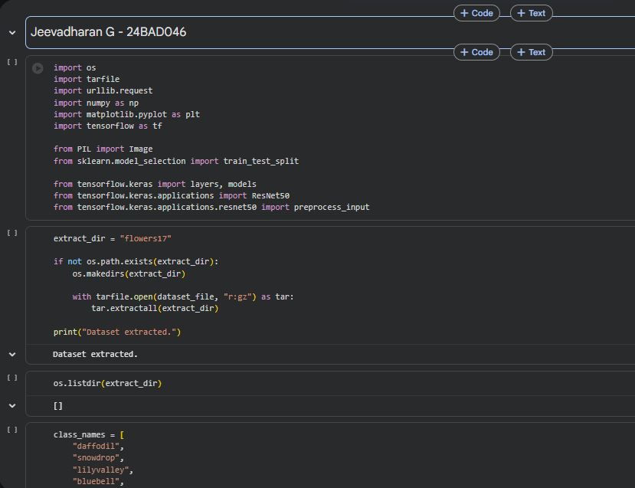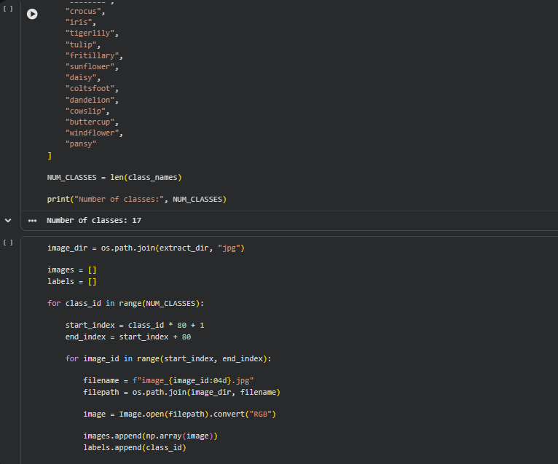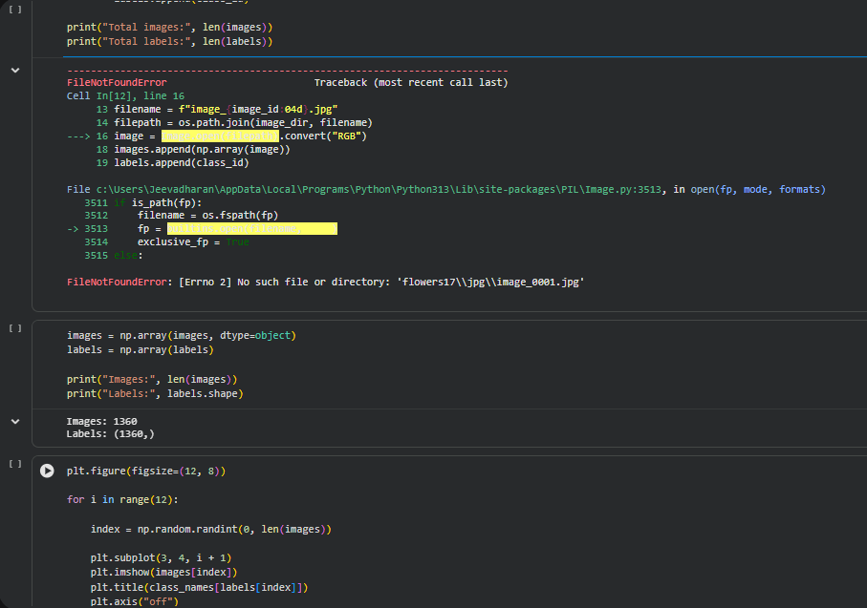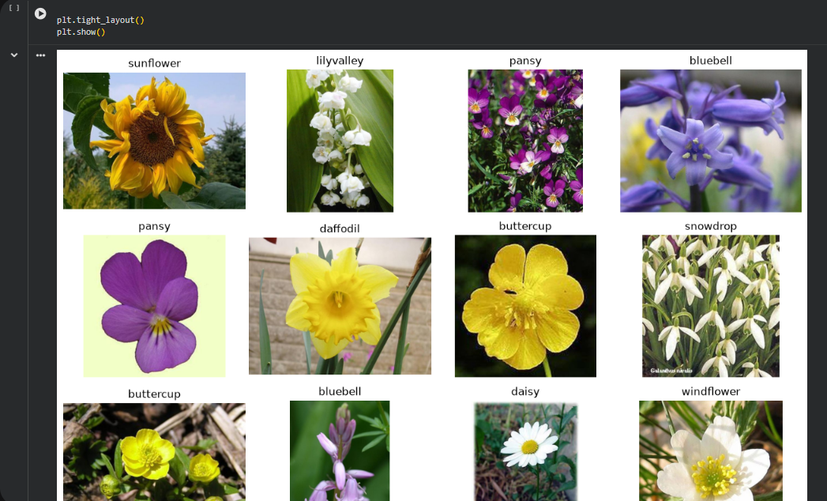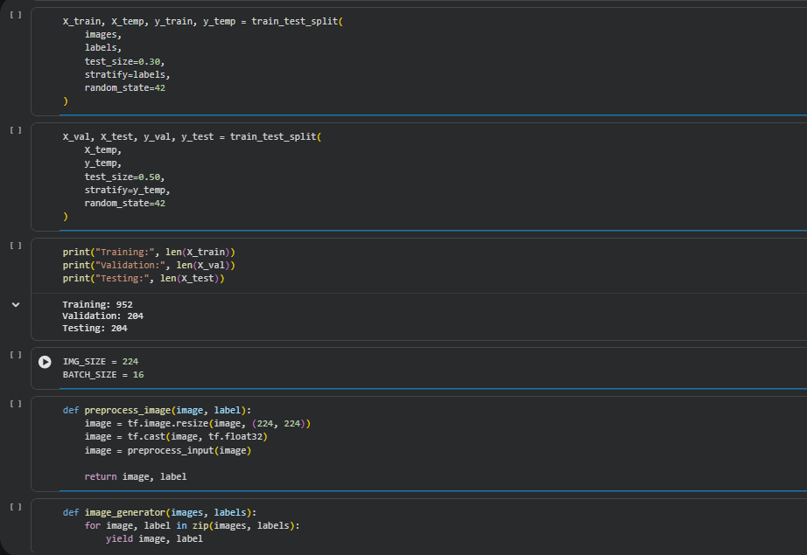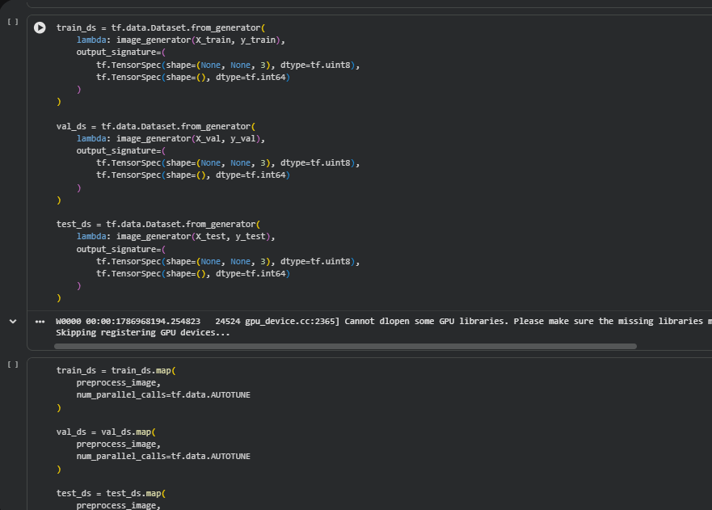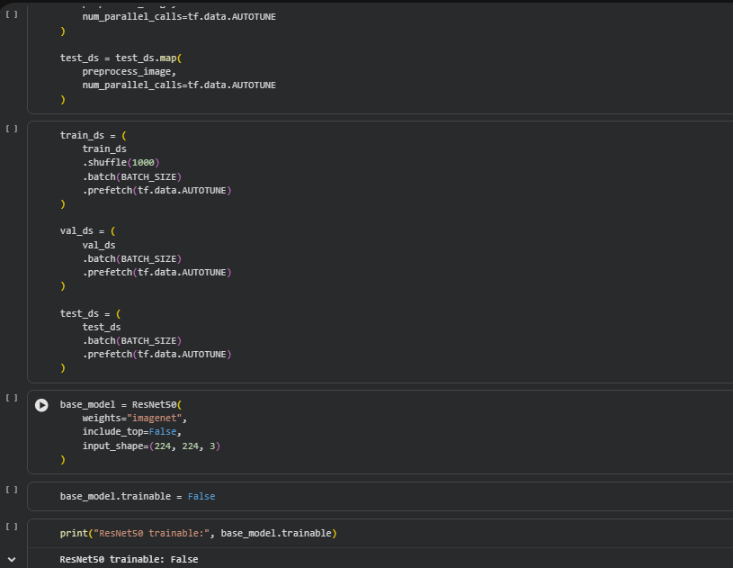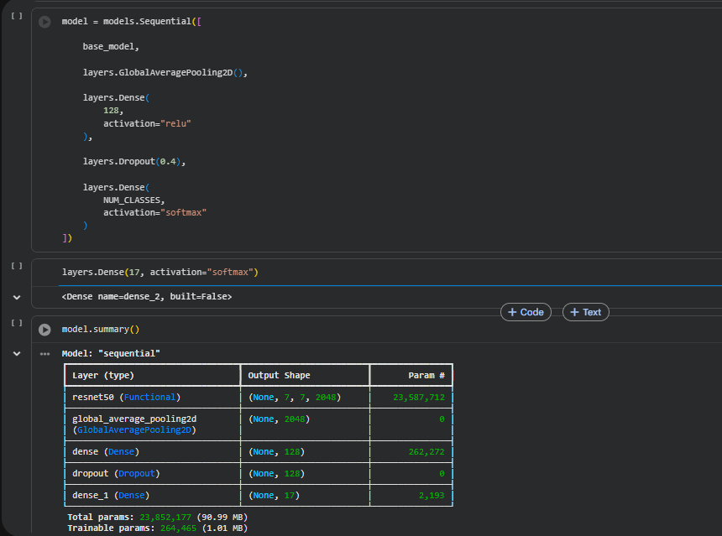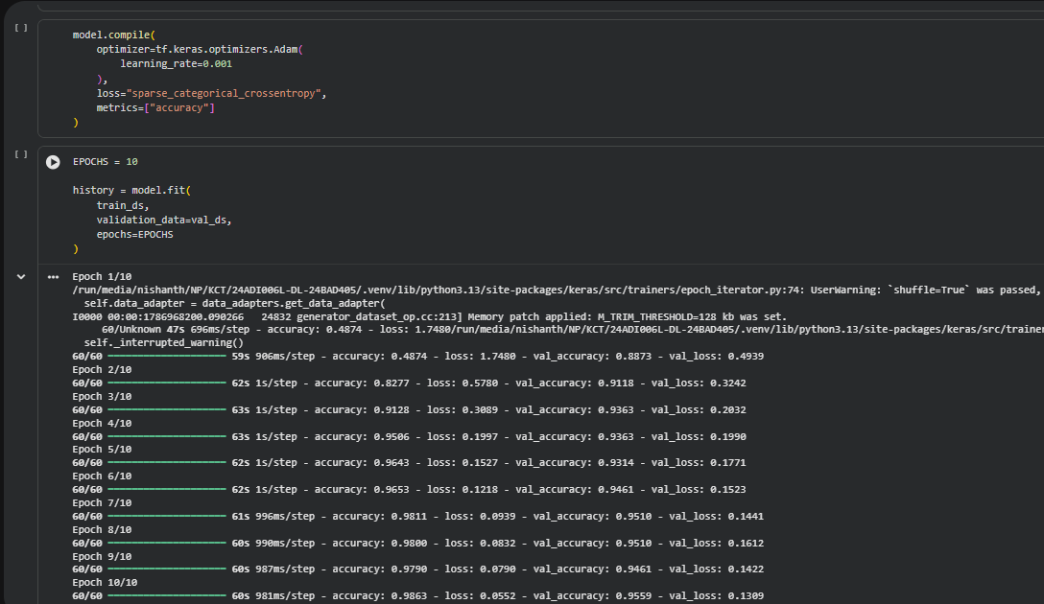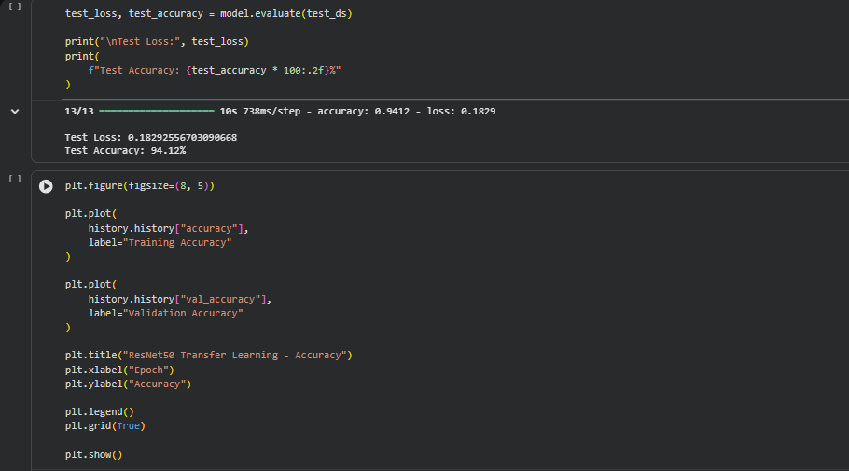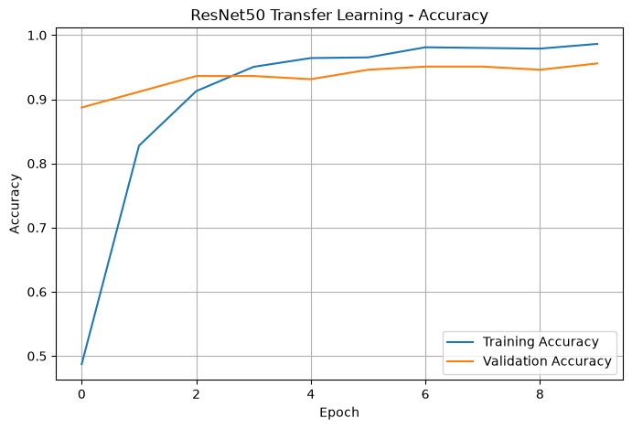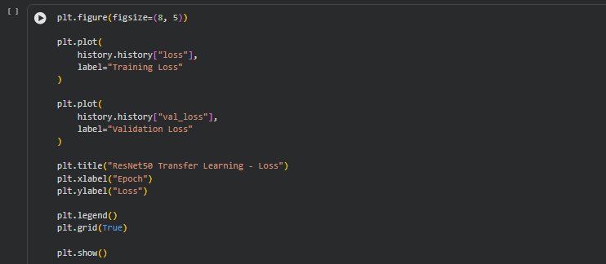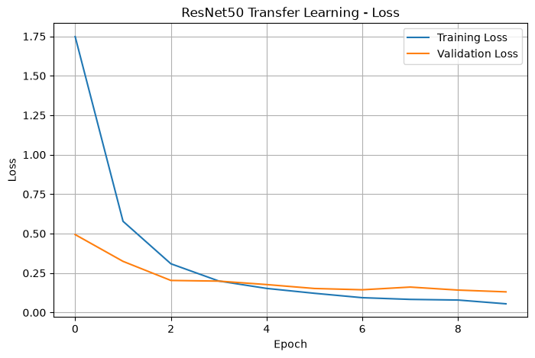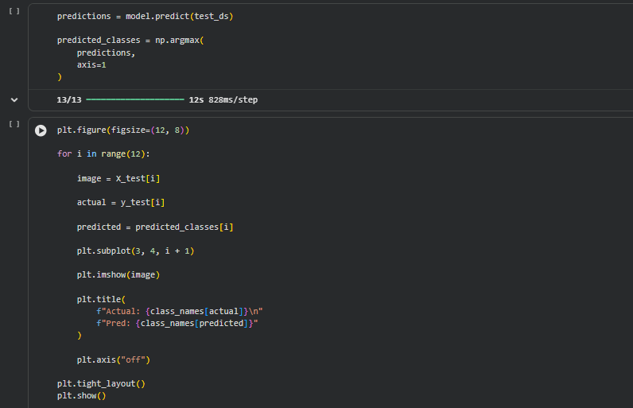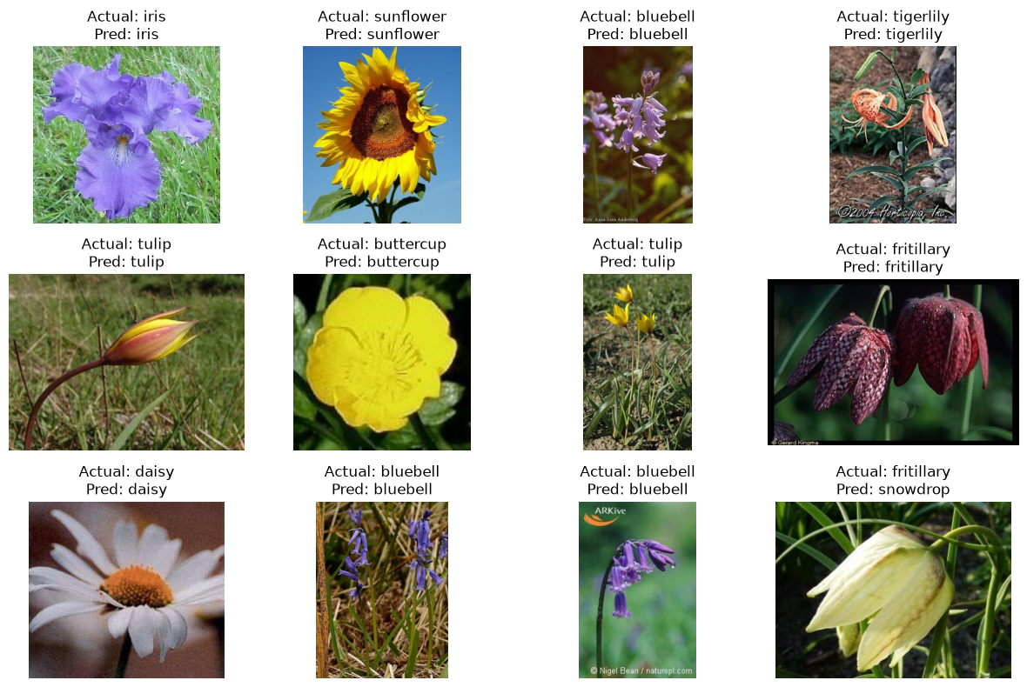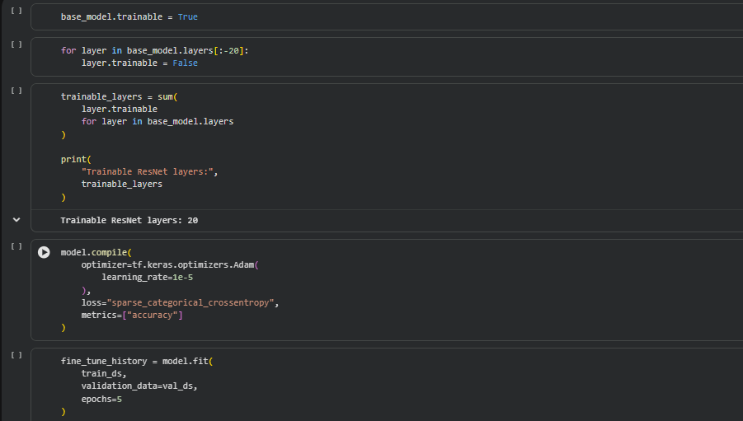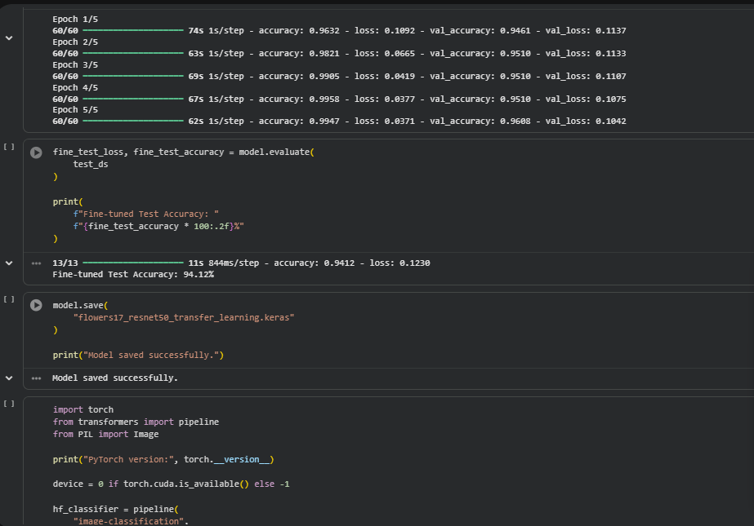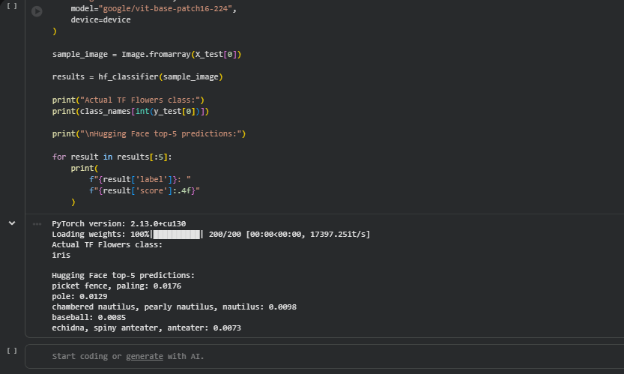
EXPECTED OUTCOME
Students will understand the advantages of transfer learning and gain practical experience in fine-tuning pre-trained vision models from TensorFlow/PyTorch and Hugging Face for image recognition tasks.

POST-LAB QUESTIONS (PROVIDE BRIEF ANSWERS TO THE FOLLOWING QUESTIONS)

- What are the advantages of transfer learning compared to training a CNN from scratch?
Transfer learning requires less training data, less computational power, and less training time. It usually provides better accuracy because the model already has useful visual features.

- Why are pre-trained models able to achieve higher accuracy with fewer training epochs?
Pre-trained models have already learned important features such as edges, shapes, textures, and patterns from large datasets. Therefore, only adaptation to the new dataset is required.

- Compare the performance of the transfer learning model with the CNN implemented in the previous experiment.
The transfer learning model generally achieves higher accuracy and converges faster than a CNN trained from scratch. This is because ResNet50 already contains useful features learned from ImageNet.

- What is the purpose of freezing layers during transfer learning?
Freezing layers prevents their weights from being changed during training. This preserves the features learned from the original dataset and reduces training time and computational requirements.

- How can Hugging Face simplify the deployment and experimentation of vision models?
Hugging Face provides ready-to-use pre-trained models and simple APIs. Users can load, test, fine-tune, and deploy vision models without implementing the complete architecture from scratch.

ASSESSMENT
Description | Max Marks | Marks Awarded
Pre Lab Exercise | 5
In Lab Exercise | 10
Post Lab Exercise | 5
Viva | 10
Total | 30
Faculty Signature

